**MULTIPLICATION USING REPEATED ADDITION:**

**ALGORITHM:**

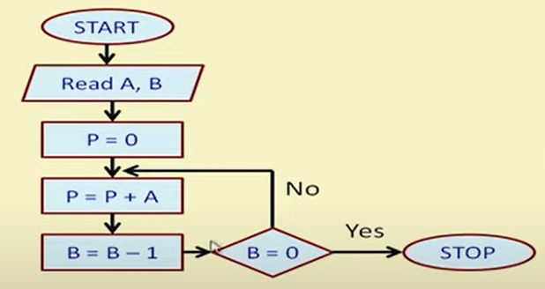

**DATAPATH:**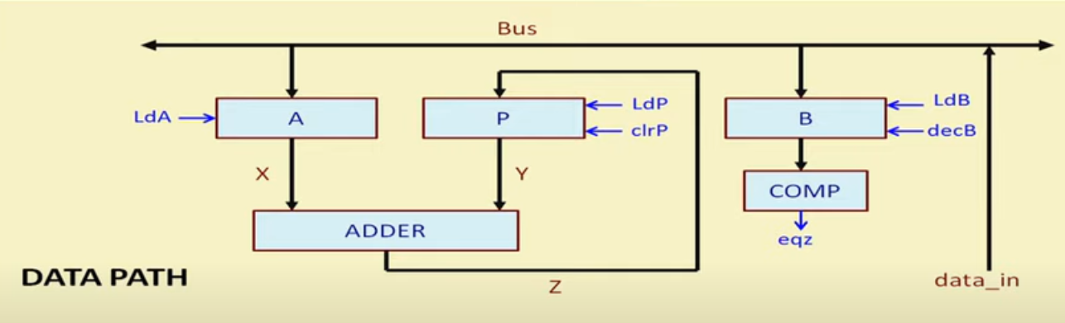

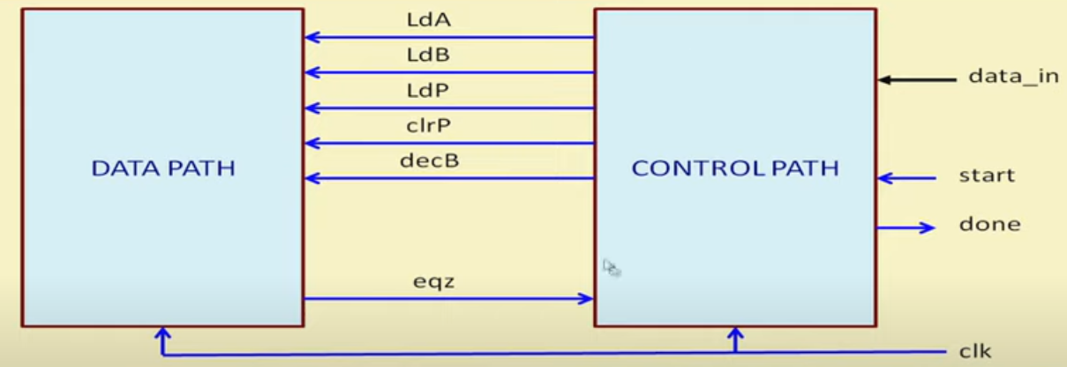

**CONTROL PATH:**

